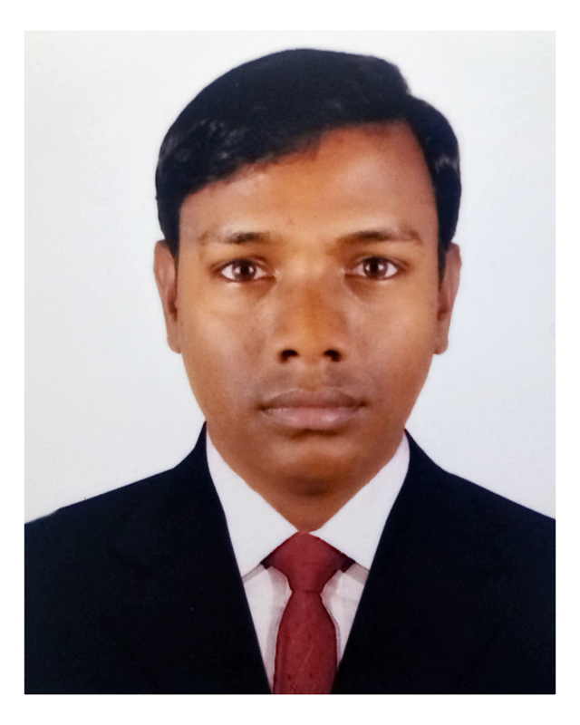
CURRICULUM VITAE OF

MOHAMMAD NAZMUL HASAN
Address: House# 235(1st Floor),Free school Street, Kathalbagan,
Dhanmondi, Dhaka 1205.
Mobile : 01736701406 / 01918356804
E-mail : hmnazmulhasan1890@gmail.com

CAREER OBJECTIVES

Building up career in a challenging and rewarding position in a reputed organization where creativity, sincerity, and performance are the criteria for ones appraisal and recognition.
Employment History

Total Experience: 4.1 years

01 Relationship Officer (July 01, 2019 to Till Today)

Brac Bank Limited.

SME Banking Division, (Small Business)
Company Location: Uttara Sonargaon Janapath Branch, House#18.Sector#09, Uttara, Dhaka-1230.

Duties/Responsibilities:
Selling SME loan, Over Due Collection and Deposit Collection etc.

02 Business executive (February 15, 2016 – February 26, 2019)

LankaBangla Finance Limited.

Department: Auto-Loan.
Company Location: Uttara tower,(level 05),plot 01, Jashimuddin Avenue, uttara model town uttara ,Dhaka 1230.

Duties/Responsibilities:

Selling consumer product mostly Auto Loan.
Coordinate with RM & Branch Manager; preparing monthly, weekly & daily reports.

03 Surveyor (August 27, 2013 – January 15, 2014)
Holcim Cement Bangladesh ltd.
Company Location: House #8, Road # 14, Baridhara Dhaka 1212.
Department: Market Research

Duties/Responsibilities:
Survey on market demand, quality and reliability of Holcim Cement

04 Surveyor (May 5, 2012 - January 7, 2013)
Sirius Marketing and Social Research Ltd.
Company Location : House No. 15/A, Road No. 5 Block-F, Banani Dhaka 1213.
Department: Market Research.
Duties/Responsibilities:
Survey on test & preferences of smokers on Benson & Hedges, Goldleaf, Marlboro etc.
Academic Qualification

Exam Title | Concentration/Major | Institute/Board | Result | Passing Year | Duration
MBA | Accounting | World University of Bangladesh | CGPA-3.60  out of 4 | 2016 | 1 year
BBA (Hons.) | Accounting | World University of Bangladesh | CGPA-3.63  out of 4 | 2015 | 4 years
HSC | Commerce | Dhaka | GPA:4.50  out of 5 | 2010 | 2 years
SSC | Commerce | Dhaka | GPA:4.25  out of 5 | 2008 | 2 years

PERSONAL SKILLS

- Written and Oral fluency, both in Bangla and English.
- Flexible, adaptable, and both willing and able to learn quickly.
- Able to generate innovative ideas.
- Constructive and diplomatic team player with strong communication skills.

COMPUTER SKILL

MS Word, MS Excel, MS Power Point, Internet Browsing, Photo editing, Video & Music editing etc.

INTEREST & HOBBIES

- Writing
- Reading Books & magazine.
- Playing Cricket, badminton &Football.
- Visiting different area etc

Achievement: Achieving “DINE WITH MD” for better performance from Lankabangla Finance ltd.

PERSONAL PROFILE

Father’s Name | : | Mohammad Abul Hossain Sheikh
Mother’s Name | : | Rahala Begum
Date of Birth | : | December 11, 1992
Gender | : | Male
Marital Status | : | Married
Nationality | : | Bangladeshi by birth
National Id No. | : | 2832647156
Religion | : | Islam
Permanent Address | : | vill- Chor Khan Khana Pur,P.O-Khan Khana Pur,P.S-Rajbari, Dist-Rajbari.
Current Location | : | Dhaka

REFERENCES:
 |  | Reference: 01 | Reference: 02
Name | : | Md Osman Sheikh | Mr. Shabuz Mahmud
Organization | : | Kazi Firms Ltd. | World University of Bangladesh
Designation | : | Manager | Senior Lecturer
Address | : | East Goalpara, Thakurgaon Town, Thakurgaon District. | Plot - 3/A, Road-4 Dhanmondi, Dhaka - 1205
Phone (Off.) | : |  | 961 1410
Mobile | : | 01732-437170 | 01717-014442
E-Mail | : | osman.sheikh@kazifarms.com | shabuz_34ru@yahoo.com
Relation | : | Brother | Academic

Date with Signature



Mohammad Nazmul Hasan

